2025
Annual Report

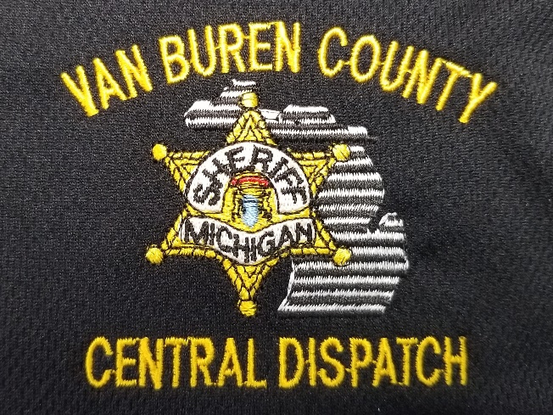

Prepared by:
Tim McGee – 911 Director
Van Buren County Central Dispatch

Summary Overview

The 2025 Annual Report is submitted to the 911 Advisory Board highlighting the work of the Van Buren County Central Dispatch (VBCCD) staff, including both 911 Dispatchers and Supervisors. These incredible people are committed to providing the most professional, and compassionate service to the citizens, public safety personnel, and visitors to Van Buren County. To provide the 24/7/365 service of 911 emergency communications, they have selflessly completed their tasks every day and sacrificed more than most as the unseen public servants of Van Buren County.
VBCCD staff have faced the various challenges thrown at them throughout 2025 with patience & perseverance. This incredible staff encountered such things as intense call volumes, equipment challenges, software upgrades and implementations, scheduling, staffing challenges, significant overtime, and the ever-present concerns with everyday family matters.
We want to thank the Van Buren County Board of Commissioners, Sheriff Abbott, and the 911 Advisory Board for their support and encouragement throughout this year. We also thank the citizens of Van Buren County for their ongoing support of 911. As staff, we do not take for granted that support and the mission that has been entrusted to us.

911 Advisory Board (2025)
Chairman – Mike Chappel – Van Buren County Board of Commissioners Appointee
Vice Chair – Dennis Reynolds – Van Buren County Medical Control Authority Representative
Tina Leary – Van Buren County Board of Commissioners Appointee
Daniel E. Abbott – Van Buren County Sheriff
Lt. Rusty Ernestes – Michigan State Police Representative
Chief Jay Allen – Van Buren County Chiefs of Police Association Representative
Chief Steve Richardson – Van Buren County Fire Chiefs Association Representative
Mr. Ross Stein – Michigan Township Association Representative
Dep. Ray Hochsprung – Van Buren County Emergency Management Representative
Mr. Mike Toth – Public Appointee

Van Buren County 911’s Mission
Van Buren County Central Dispatch serves our citizens, visitors, and public safety agencies by providing critical communications link to emergency services, through compassionate, courteous, and professional dispatch services.

VBCCD - Objectives & Priorities
- Receive and process emergency 911 calls from the public in a timely and efficient manner.

- Deploy appropriate and necessary resources to meet the emergency needs for mitigation and elimination of the incident.

- Provide communication and related support services to public safety agencies.

- Appropriately prioritize, disseminate, and/or refer requests for emergency services.

VBCCD - Ethics Pledge
- We are members of an important and honorable profession.
- We recognize that respect, esteem and integrity are not handed out when you are hired as a 911 Telecommunicator of the Van Buren County Central Dispatch Center. These values are expected of each member of the center.
- We hold ourselves to the highest levels of truthfulness, respect, accuracy, and accountability, to the agencies we serve and the public we protect.
- As professionals, we are committed to conducting ourselves in a manner that does not promote a perception of unethical behavior or conflict of interest.
- The individual’s right to privacy will be balanced with the goals and ethics of the Van Buren County Central Dispatch Center.
- Adhering to this Ethics Pledge and its principles reflect the honor and pride in our individual employees’ and our collective mission as a Public Safety Agency.

“What is right is not always popular,
And
What is popular is not always right!”

We Strive for Excellence NOT Perfection

Staff Recognition
The following VBCCD staff were recognized throughout 2025 for outstanding performance by the 911 Advisory Board at their quarterly meetings.
January: Dispatcher / CTO Brooke Smith –Stork Award
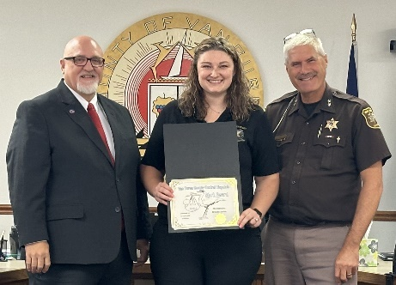
Stork Award, including Stork Pin, Certificate & Letter of Commendation

April: Dispatcher / CTO Chad Kirby
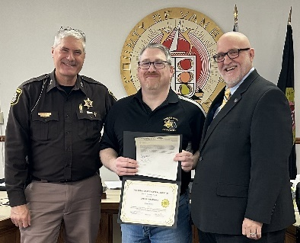
Life Saving Award – incudes a Certificate & Letter of Commendation

July: Dispatch Team Commendation – Severe Weather Event (3 busiest hours of the year)

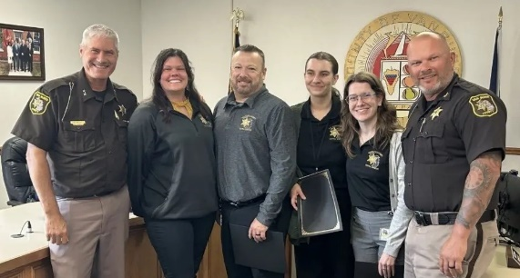
Supervisor Mike Hostetler
Dispatcher Emily Stroh
Dispatcher Alison Dean (not present)
Probationary Dispatcher Kristen Featherstone
Trainee Dispatcher Bree Smiles

October: Dispatcher Melissa Dunckel
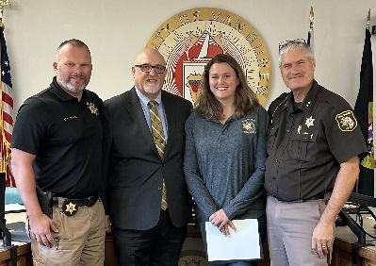
Certificate & Letter of Commendation for her handling of a SWAT call with homicidal and barricaded subject

Dispatcher / CTO – Brianna Dobberstein
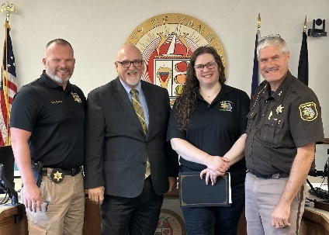
Life Saving Award - Certificate & Letter of Commendation for her handling of CPR call

Dispatcher / CTO – Brooke Smith
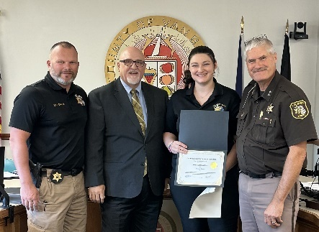
Life Saving Award - Certificate & Letter of Commendation for her handling of CPR call

Statistical Report
Staffing:
- The current complement of allocated 911 staff sits at a total of 18
  - 1 Director
  - 1 QA / Training Supervisor
  - 2 Shift Supervisors
  - 14 Dispatchers
- The average age of current staff is 34 years old with an average of 3 years of experience
- 20 separate staff members worked during 2025
- 7 new staff members hired in 2025
- Turnover – 5 staff members = 25% (National avg. 29%)
  - 4 to resignation or termination / 3 failed to complete initial training
  - 1 left for the police academy & now a deputy for the Van Buren County Sheriff
- Recruiting, hiring, and training a 911 team member often takes 6-9 months before they can function as a solo dispatcher. Over the course of 2025:
  - 95 Applications processed
  - 34 Applicants eligible & invited to testing
  - 27 Applicants responded & completed testing
  - 15 Applicants were invited to interview
  - 3 Applicants successfully completed background investigations & given conditional offers of employment

- Hours worked:
  - Regular hours 23,652
  - Overtime 1,502
  - PTO/Personal 2,335 (47 sick days)
  - Holiday (not worked) 796
  - Holiday (worked) 980
  - Bereavement 128
  - Other 382 (includes disability / FMLA etc.)
  - TOTAL HOURS 29,775

Training:
- Basic new hire training hours 4,693
- Continuing Education hours 1,144
- 5 staff attended the State 911 Conference
- Conferences / Training attended:
  - New supervisors’ school
  - Communication Training Officer school
  - 40-Hour Basic Dispatch school
  - 40-Hour Advanced Dispatch School
  - MPSCS Statewide Interoperability Conference
  - State 911 Emerging Technology Forum
  - PFN User Group Training
  - NENA / APCO
  - Michigan Communication Director’s Association (MCDA) training
  - Numerous on-line training concentrating on EMS / Fire / Police dispatch
Court Paperwork: – Warrant & Order entry / recall / validations
- VBCCD remains as one of only a handful of dispatch centers in Michigan that handle the entry, cancellation, modification etc. of warrants & court orders (except for entering Friend of the Court warrants). The handling of court paperwork places a significant workload on the VBCCD staff, who pride themselves on the accuracy and timeliness of such entries.
- VBCCD successfully completed a tri-annual LEIN audit. Items of note were an error rate of .003% for handling court paperwork.

Phone Activity:
The primary task that any dispatcher accomplishes is Call-Taking. It is foundational to the operation of an Emergency Communications Center (ECC) and the starting point of nearly all Calls for Service (CFS). In 2025, VBCCD staff answered more than 108,000 phone calls, with 34% of these phone calls coming in via 9-1-1. Dispatchers utilized a texting function within the 911 system to resolve over 2000 accidental calls, hang up calls, and other calls where the caller could not communicate via a voice call. Not all emergency calls arrive in the ECC via the 911 system and the staff answered an additional 55,000+ calls via our regular 10-digit telephone lines. Calls volumes from both 911 & 10-digit phone lines follow a similar flow as to time of day & day of the week.
- VBCCD phone volume – during the following time frames a dispatcher answer a phone call:
  - 12am-6am = every 15 minutes
  - 6am-12pm = every 5.8 minutes
  - 12pm-6pm = every 3.9 minutes
  - 6pm-12am = every 5.8 minutes

The graphs below provide us with important information and data that assists us in evaluating staffing levels & scheduling.

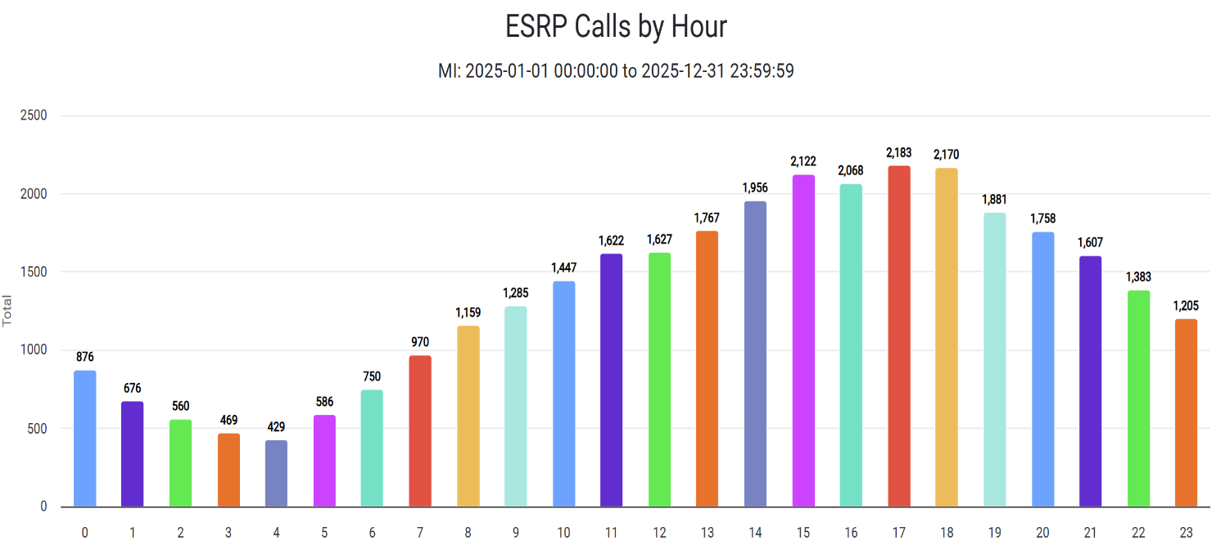
2025 - 911 Calls – YTD - Hour of the Day
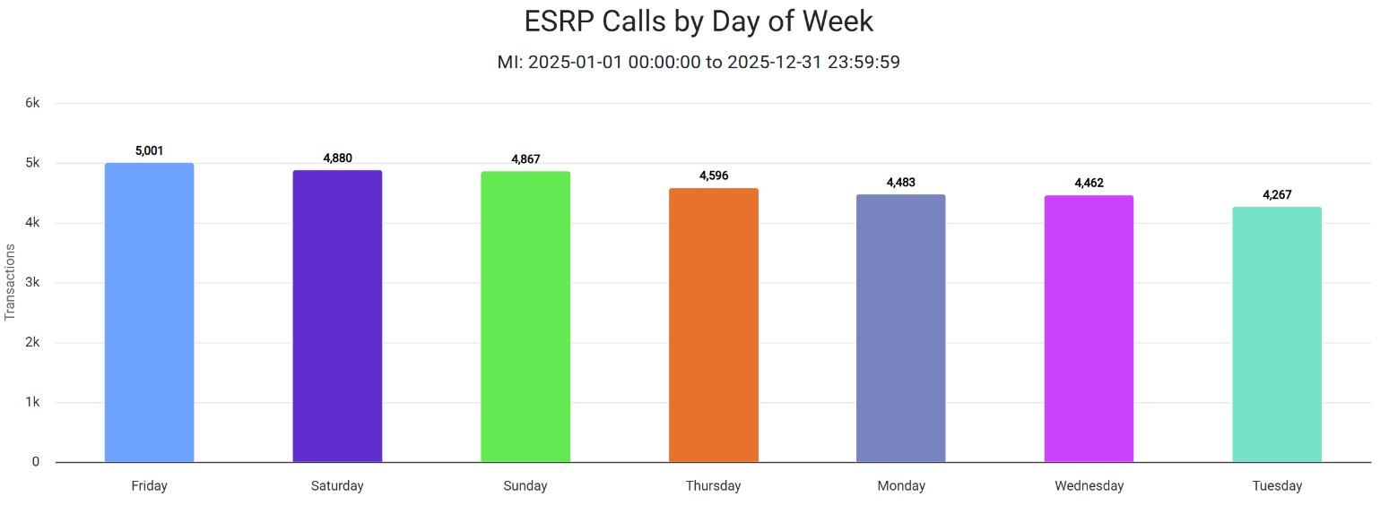
911 Calls – YTD - Day of the Week

Calls For Service (CFS): The below statistics are Calls for Service dispatched
- Total calls for service were down across the board 2% from 2024
- Police CFS – down 6%
- Traffic Stops – down 7%
- Animal Control CFS – down 15%
- EMS CFS – up 4%
- Fire CFS – up 12%
- Misc. CAD/CFS – up 8%

Financial / Funding

VBCCD is funded solely through 911 Surcharges. The State 911 Surcharge provides 8% of the funding, with the other 92% generated through the 911 Local Surcharge. There is no additional millage, or general fund tax dollars that assist with the delivery of 911 services in the county. We are grateful again to the citizens of the county who have historically supported the financial needs of 911 by voting in the affirmative for the 911 Local Surcharge to remain at the statutory cap of $3.00 per/month (less than the cost of a Happy Meal).
VBCCD finances continue to maintain a healthy fund balance with a forward look towards future expenditures. Upgrading current facilities, radios, software, and other infrastructure is a constant need, therefore, conservative yearly expenses are closely monitored. There is a continual evaluation and commitment to the need for investing in our most important resource which is the staff of the center.

Financial Summary – FY 2024-2025
Fiscal Year = October through September

Capital Projects

- Dispatch Center Refresh project completion:
  - VBCCD has been located at the Van Buren County Sheriff's Office since its inception & in the current basement location since 2000. With no foreseeable plans for relocation, in 2023, a project was developed to refresh the current center (room) and budgeted for in the 2023-2024 FY. The project plan included the reallocation of approx. 180 square feet from the Emergency Operations Center to the Dispatch Center. It also includes fresh paint, carpet, cabinets, and the reuse of the current dispatch console furniture. The project was delayed several months, as it was moved from the 911 budget and subsequently added to the county’s capital improvement project list. This project was completed in February 2025 and has provided a much-needed breath of fresh air to the staff.
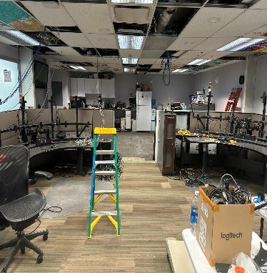
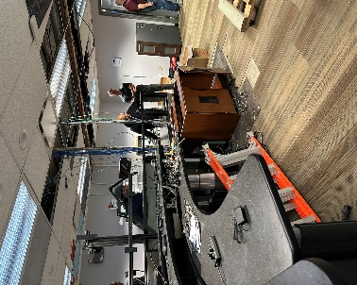
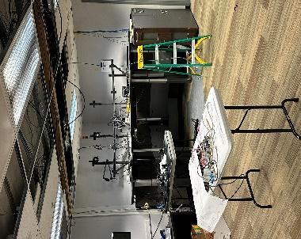
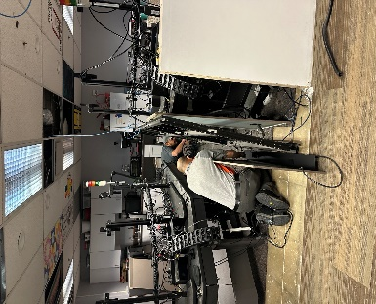

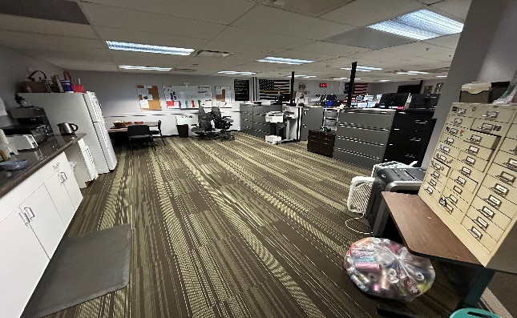
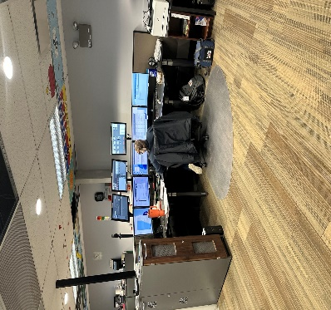
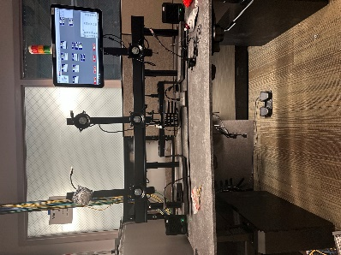

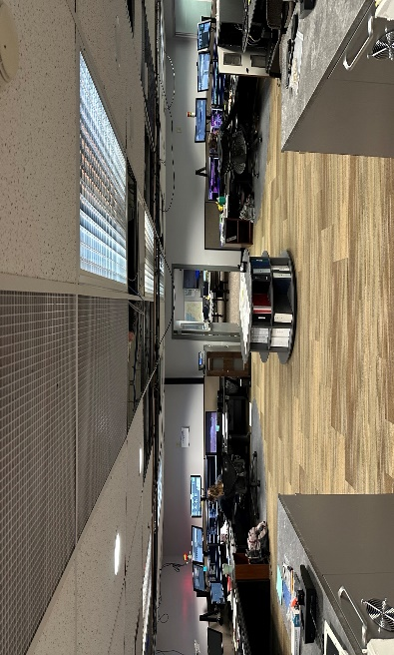
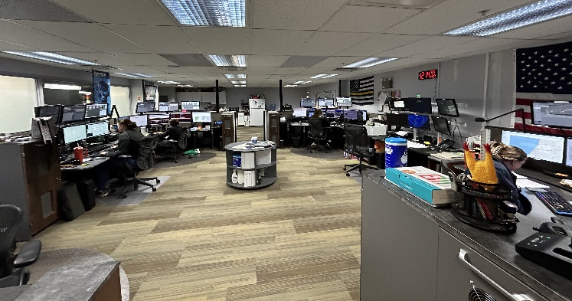

Miscellaneous Projects:
- Deployment of the RapidSOS GIS module.
- Deployment of the RapidSIS AI generated Alarm Call Automation module.
- Currently in progress is the deployment of the RapidSOS language translation / transcription “Communicator” module.
- Audio Recording refresh.
- Coordinate with Van Buren County Emergency Management with required FEMA / NRC drills for the reopening of the Palisades Nuclear Power Plant.
- Re-implementation of the Emergency Police Dispatch Protocols (EPD)
State 911 Certification Audit
VBCCD was randomly drawn for an audit from the State 911 Certification subcommittee in May. This process is ongoing and due to the Federal Government shutdown in the fall of 2025, a final report is not anticipated until March of 2026. This audit is to review compliance with P.A. 32 (the 911 Act) and looks at finance records for the past 5 years. It also includes an on-site visit, interviews with dispatch staff, public safety partners, administrative staff, review of all policy/procedures, the physical facilities etc.

911 Director Succession Planning
Having determined that the time was approaching for retirement, we developed a succession plan to facilitate a smooth transition between 911 Directors. Mike Hostetler was ultimately selected to succeed Tim McGee as the next 911 Director for VBCCD. Mike has been with VBCCD for 26 years and is well respected within the 911 community. A 4-month Director Training Program was developed and implemented as part of our succession plan. Mike will officially begin his duties as the 911 Director for VBCCD on February 1, 2026.

Summary - Conclusion
The 911 staff of Van Buren County Central Dispatch (VBCCD) continue their commitment to provide exemplary and professional emergency communications services. Central Dispatch remains a busy center of activity that includes both 911 and administrative phones, radio communications for all public safety agencies servicing Van Buren County, as well as multiple support services. VBCCD staff are proud to be the silent, unseen, and dedicated public servants maintaining their watch 24/7/365.
On a personal note, it is bittersweet to produce this 2025 Annual Report as I enter into the season of retirement on January 31st , 2026. I have truly loved serving here at Van Buren County Central Dispatch. So many wonderful memories, challenges, delights to list, however, it has been a wonderful journey and I am grateful. I want to say THANK YOU to our 911 staff, Sheriff Abbott, the 911 Advisory Board, the Board of Commissioners, our Public Safety Partners and the myriads of citizens that have been supportive of our mission and mindset. It has been my privilege to serve each of you. May God bless you in the days to come.

Tim McGee – ENP, CMCP
911 Director-Retired

